

Laboratory work #3

Performance, Data Structure & Algorithms

“Heap Sort”

Group:ITDS-1901

Ibrayeva Madina

1. Implement Heap sort using any programming languages.

if b<arr.lenght and arr[i]<arr[b]

largest = b

if a<arr.lenght and arr[largest]<arr[a]

largest = a

if largest!= I

arr[i], arr[largest] = arr[largest], arr[i]

for index in range(arr.lenght//2-1, -1, -1)

heap_sort(arr, arr.lenght, index)

for index in range(arr.lenght - 1, 0, -1)

arr[i], arr[0]=arr[0], arr[i]

heap_sort(arr, arr.lenght, 0)

(code – pseudocode)

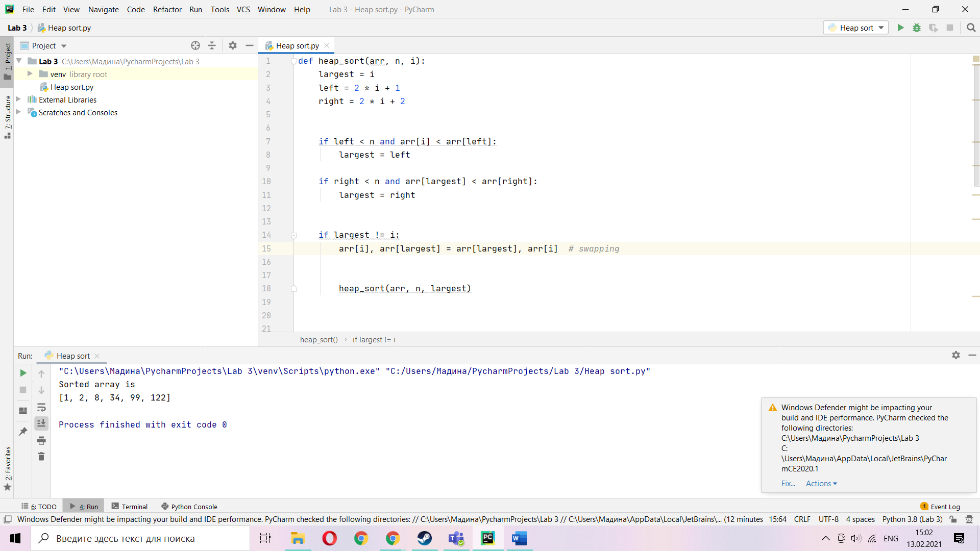

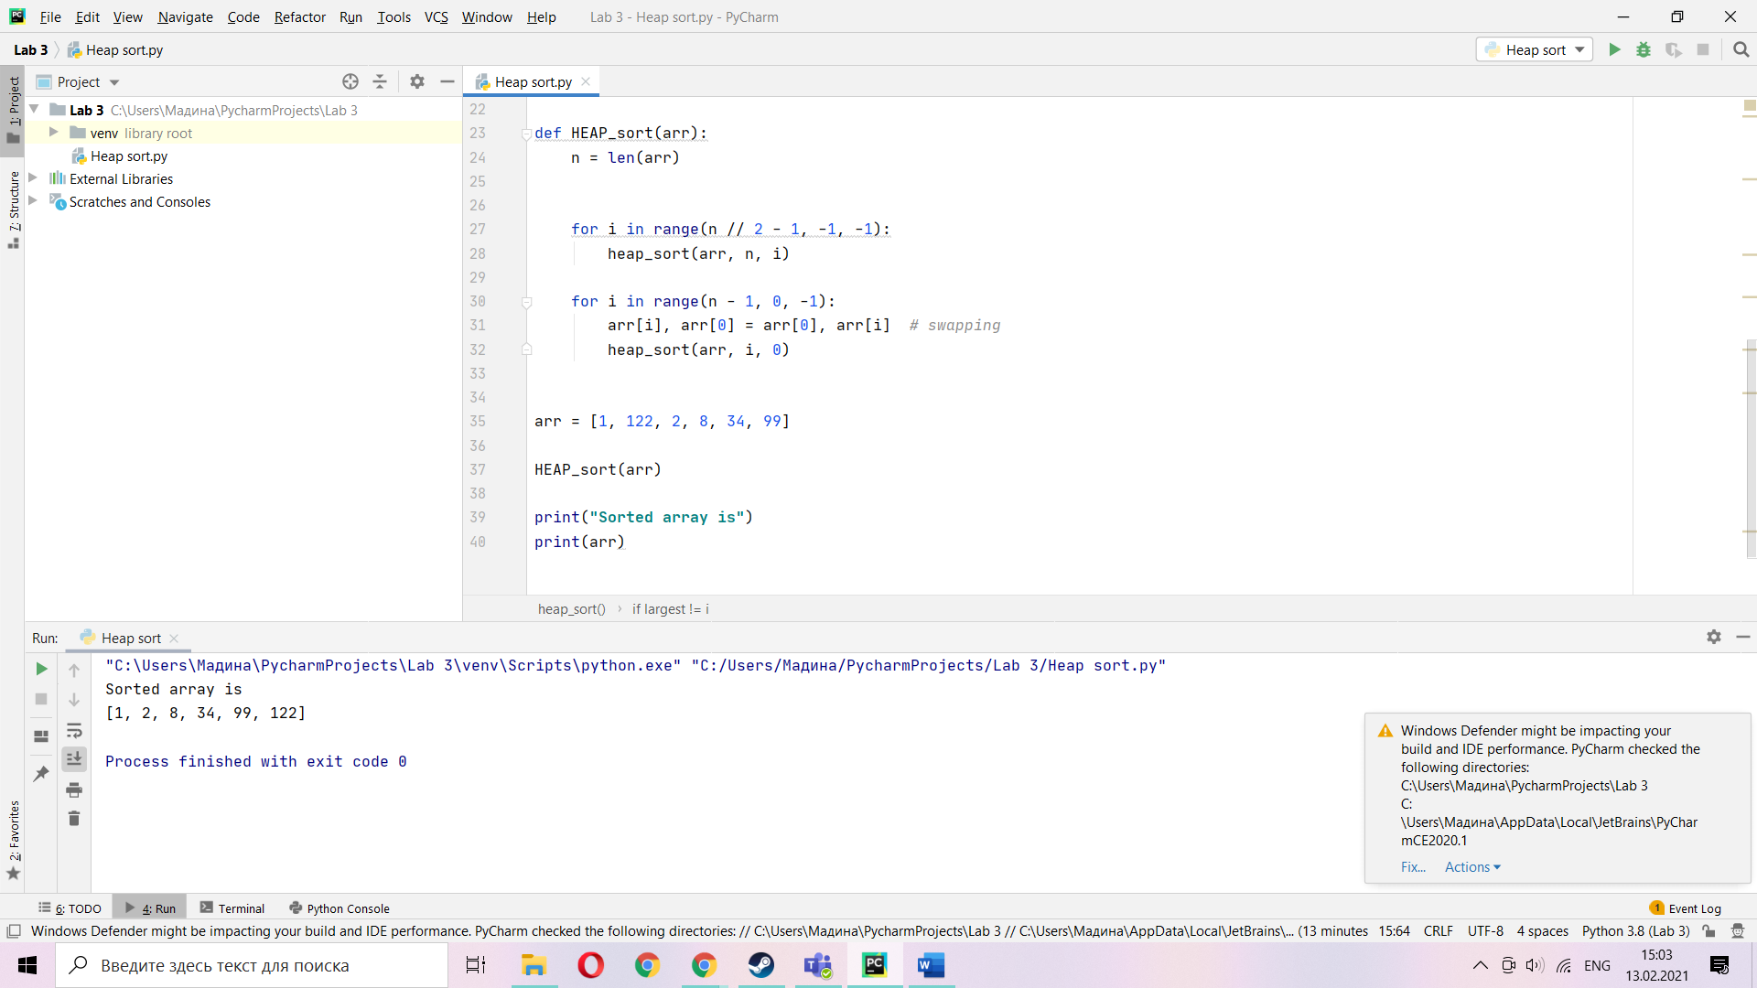

1. Using lecture as a model, illustrate the operation of MAX-HEAPIFY(A; 3) on the array A (27; 17; 3; 16; 13; 10; 1; 5; 7; 12; 4; 8; 9; 0).

(picture)

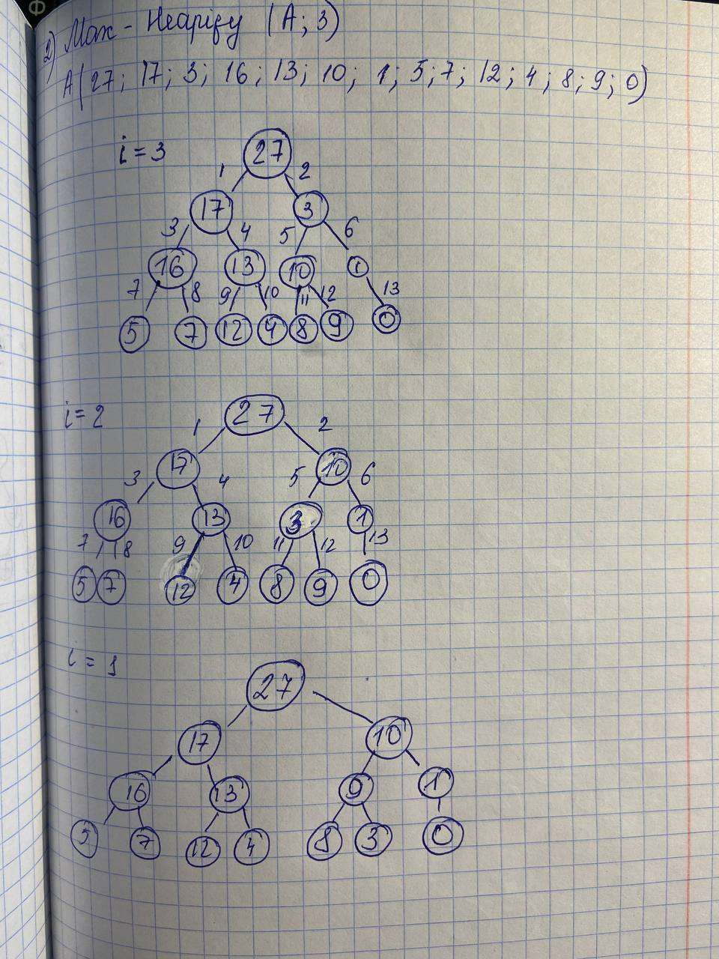

1. Using lecture as a model, illustrate the operation of HEAPSORT on the array A (5; 13; 2; 25; 7; 17; 20; 8; 4).

(picture)

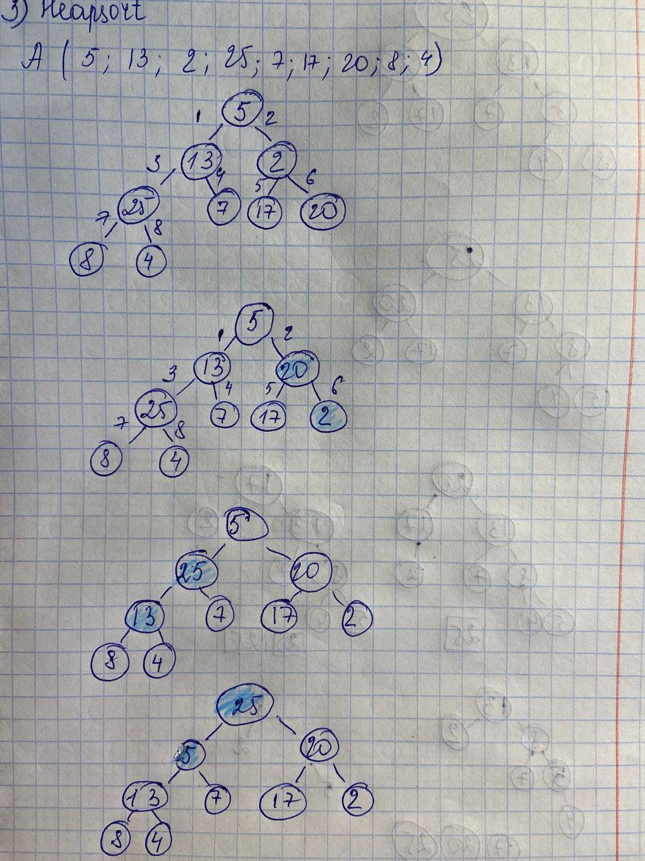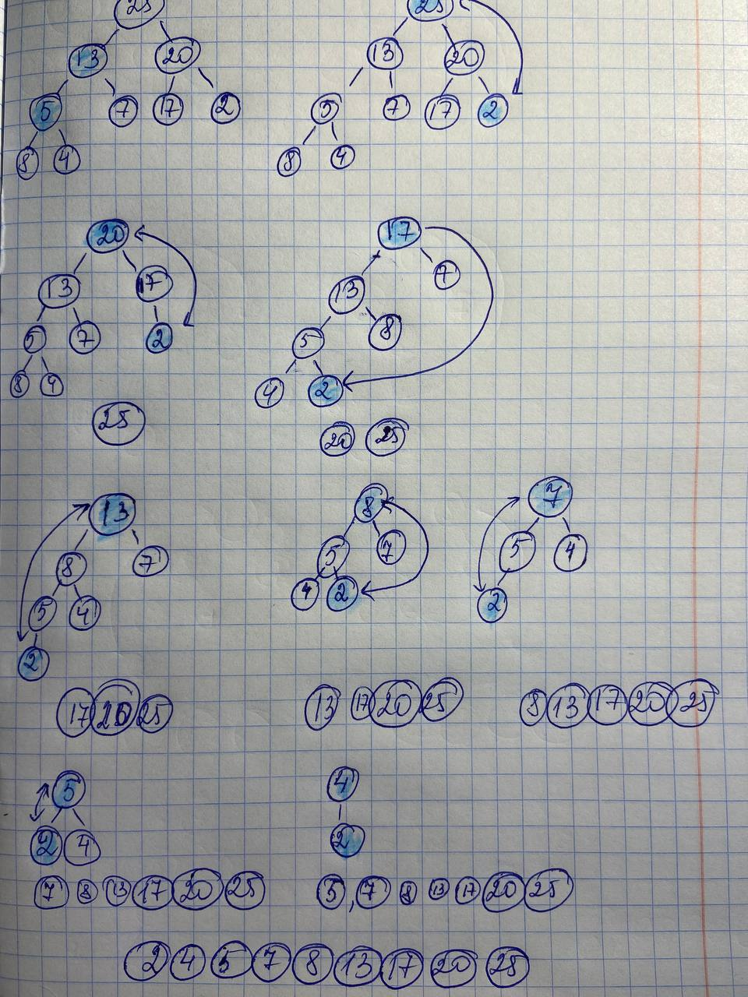

1. What is the running time of HEAPSORT on an array A of length n that is already sorted in increasing order? What about decreasing order? Show that the worst-case running time of HEAPSORT is T(n lg n).

So, when we solve this task, we should understand how heapsort works. Every element of given massive comparing with other elements, in the end every element is creating his own heap, so this time is O(n) and in massive there is n values = O(n) too. When we multiply them answer will be T(n lgn)

1. Starting with the procedure MAX-HEAPIFY, write pseudocode for the procedure MIN-HEAPIFY(A; i ), which performs the corresponding manipulation on a minheap. How does the running time of MIN-HEAPIFY compare to that of MAXHEAPIFY?

(code – pseudocode)

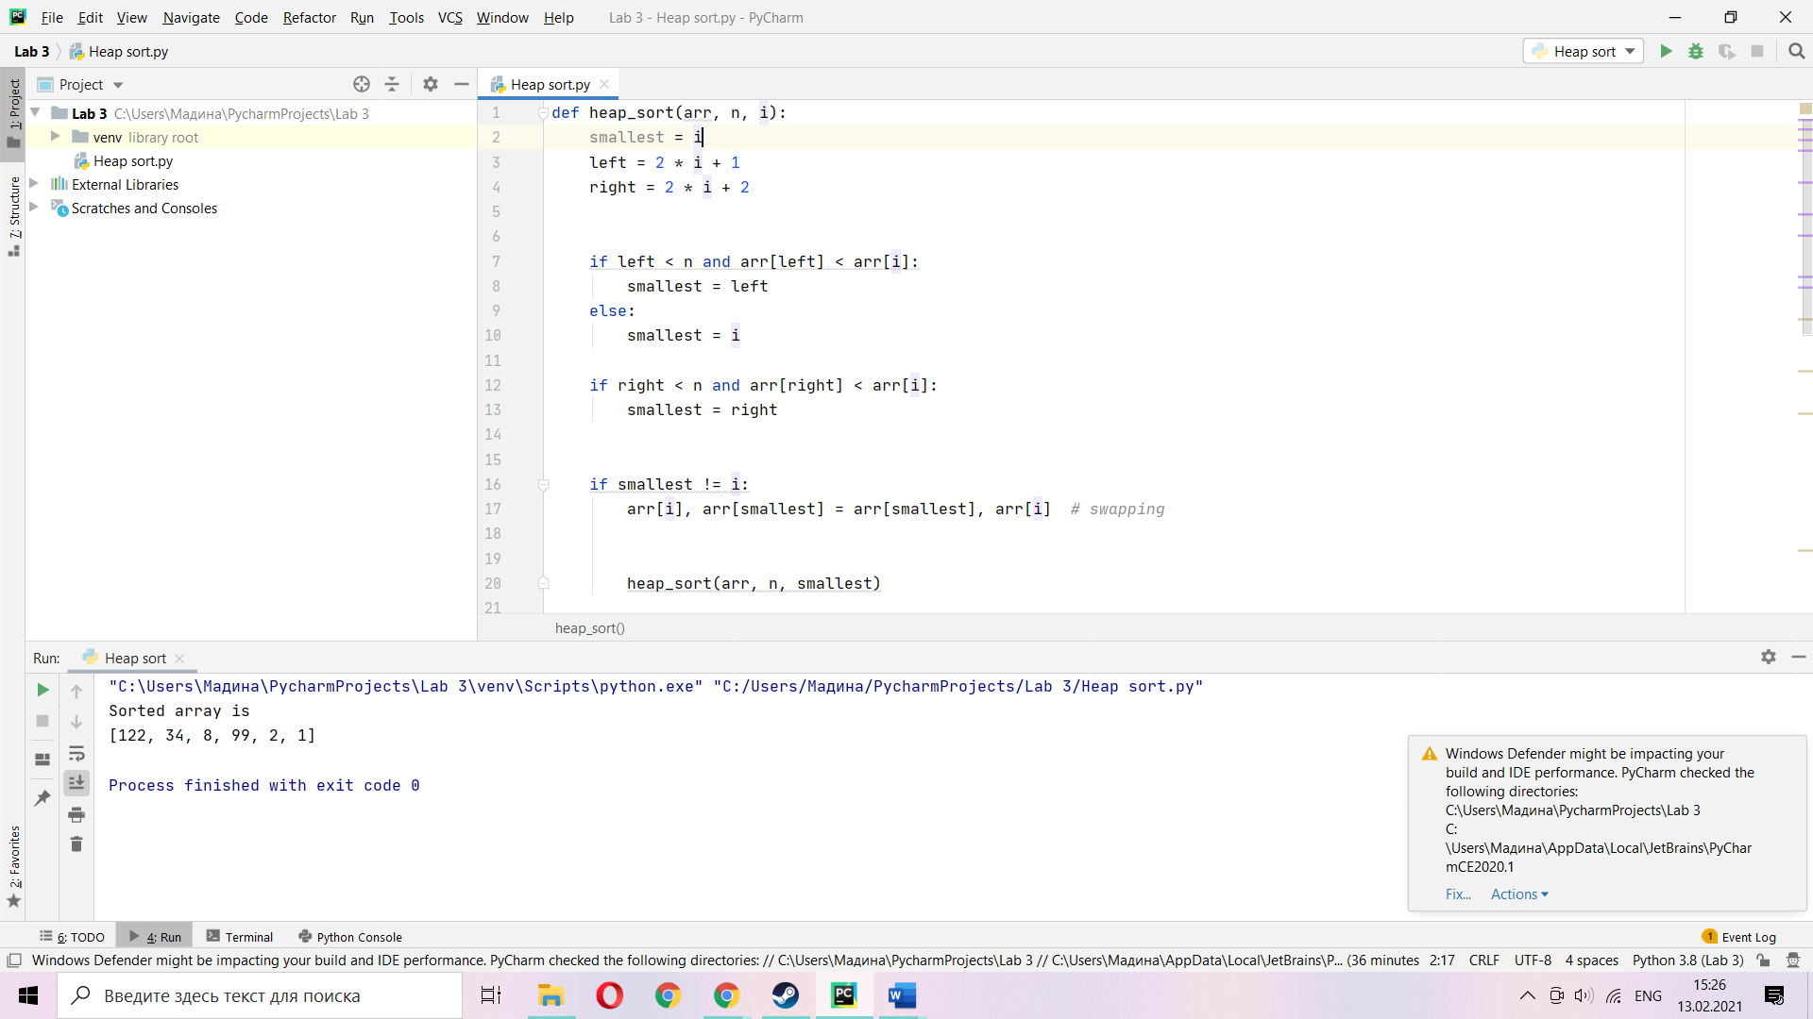

if left< arr.lenght and A[left]<A[i]

smallest = l

else

smallest = i

if r<arr.lenght and A[right]<A[i]

smallest = r

if smallest != I

A[i], A[smallest] = A[smallest], A[i]

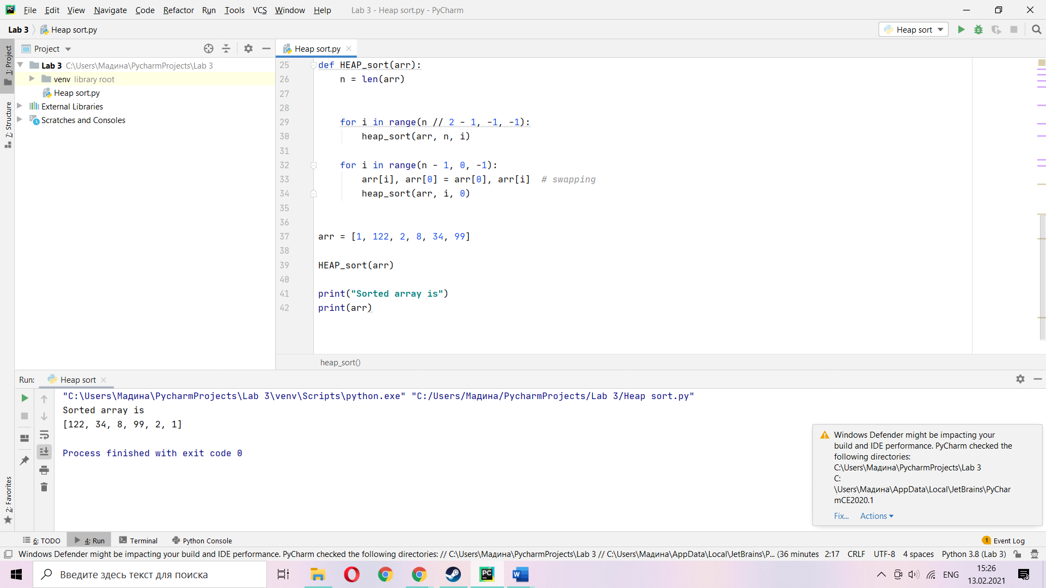

How does the running time of MIN-HEAPIFY compare to that of MAXHEAPIFY?

Actually, the structure of this two codes are similar. So, the running time will be the same , T(n lgn)